Project 1.A

- Project Description
In your first homework, you were asked to design a database that stores some information about a university. Many of you have done an excellent job. Figure 1 shows an ER diagram that is among some good ones.

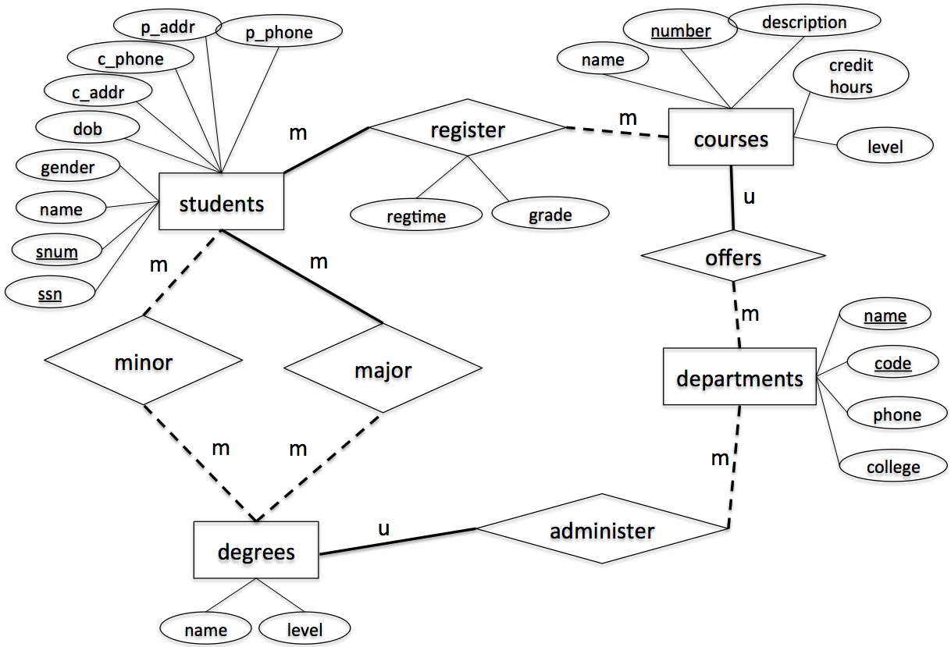

Figure 1. ER-diagram
This project is to implement the above design using a relational data model. Specifically, you are asked to write the following SQL scripts.

- CreateTables.sql [Points: 15]
This script creates the following tables. Each table must be created with the table name, attribute names and corresponding types and length as specified. Also, make sure to specify primary key, candidate key and foreign key (if any), accordingly.
- students
  - Attribute, type and length: snum: integer, ssn: integer, name: varchar(10), gender: varchar(1), dob: datetime, c_addr: varchar(20), c_phone: varchar(10), p_addr: varchar(20), p_phone: varchar(10)
  - Primary key: ssn
  - Candidate key: snum
  - Foreign key: N/A
- departments
  - Attribute, type and length: code: integer, name: varchar(50), phone: varchar(10), college: varchar(20)
  - Primary key: code
  - Candidate key: name
  - Foreign key: N/A
- degrees
  - Attribute, type and length: name: varchar(50), level: varchar(5), department_code: integer
  - Primary key: name, level
  - Candidate key: N/A
  - Foreign key: department_code refers to code in table departments
- courses
- Attribute, type and length: number: integer, name: varchar(50), description: varchar(50), credithours: integer, level: varchar(20), department_code: integer
- Primary key: number
- Candidate key: name
- Foreign key: department_code refers to code in table departments
- register
- Attribute, type and length: snum: integer, course_number: integer, regtime: varchar(20), grade: integer
- Primary key: snum, course_number
- Candidate key: N/A
- Foreign key: snum refers to snum in table students, course_number refers to number in table courses
- major
- Attribute, type and length: snum: integer, name: varchar(50), level: varchar(5)
- Primary key: snum, name, level
- Candidate key: N/A
- Foreign key: snum refers to snum in table students, name & level refer to name & level in table degrees
- minor
- Attribute, type and length: snum: integer, name: varchar(50), level: varchar(5)
- Primary key: snum, name, level
- Candidate key: N/A
- Foreign key: snum refers to snum in table students, name & level refer to name & level in table degrees

- InsertRecords.sql [Points: 15]
This script inserts the following records to the appropriate tables created by CreateTables.sql.

- students

snum | ssn | name | gender | dob | c_addr | c_phone | p_addr | p_phone
1001 | 654651234 | Randy | M | 2000/12/01 | 301 E Hall | 5152700988 | 121 Main | 7083066321
1002 | 123097834 | Victor | M | 2000/05/06 | 270 W Hall | 5151234578 | 702 Walnut | 7080366333
1003 | 978012431 | John | M | 1999/07/08 | 201 W Hall | 5154132805 | 888 University | 5152012011
1004 | 746897816 | Seth | M | 1998/12/30 | 199 N Hall | 5158891504 | 21 Green | 5154132907
1005 | 186032894 | Nicole | F | 2001/04/01 | 178 S Hall | 5158891155 | 13 Gray | 5157162071
1006 | 534218752 | Becky | F | 2001/05/16 | 12 N Hall | 5157083698 | 189 Clark | 2034367632
1007 | 432609519 | Kevin | M | 2000/08/12 | 75 E Hall | 5157082497 | 89 National | 7182340772

- departments

z | name | phone | college
401 | Computer Science | 5152982801 | LAS
402 | Mathematics | 5152982802 | LAS
403 | Chemical Engineering | 5152982803 | Engineering
404 | Landscape Architect | 5152982804 | Design

- degrees

name | level | department_code
Computer Science | BS | 401
Software Engineering | BS | 401
Computer Science | MS | 401
Computer Science | PhD | 401
Applied Mathematics | MS | 402
Chemical Engineering | BS | 403
Landscape Architect | BS | 404

- major

snum | name | level
1001 | Computer Science | BS
1002 | Software Engineering | BS
1003 | Chemical Engineering | BS
1004 | Landscape Architect | BS
1005 | Computer Science | MS
1006 | Applied Mathematics | MS
1007 | Computer Science | PhD

- minor

snum | name | level
1007 | Applied Mathematics | MS
1005 | Applied Mathematics | MS
1001 | Software Engineering | BS

- courses

number | name | description | credithours | level | department_code
113 | Spreadsheet | Microsoft Excel and Access | 3 | Undergraduate | 401
311 | Algorithm | Design and Analysis | 3 | Undergraduate | 401
531 | Theory of Computation | Theorem and Probability | 3 | Graduate | 401
363 | Database | Design Principle | 3 | Undergraduate | 401
412 | Water Management | Water Management | 3 | Undergraduate | 404
228 | Special Topics | Interesting Topics about CE | 3 | Undergraduate | 403
101 | Calculus | Limit and Derivative | 4 | Undergraduate | 402

- register

snum | course_number | regtime | grade
1001 | 363 | Fall2020 | 3
1002 | 311 | Fall2020 | 4
1003 | 228 | Fall2020 | 4
1004 | 363 | Spring2021 | 3
1005 | 531 | Spring2021 | 4
1006 | 363 | Fall2020 | 3
1007 | 531 | Spring2021 | 4

- Query.sql [Points: 55]
This script prints out the following information
  - The student number and ssn of the student whose name is "Becky"
  - The major name and major level of the student whose ssn is 123097834
  - The names of all courses offered by the department of Computer Science
  - All degree names and levels offered by the department Computer Science
  - The names of all students who have a minor
  - The number of students who have a minor
  - The names and snums of all students enrolled in course “Algorithm”
  - The name and snum of the oldest student
  - The name and snum of the youngest student
  - The name, snum and SSN of the students whose name contains letter “n” or “N”
  - The name, snum and SSN of the students whose name does not contain letter “n” or “N”
  - The course number, name and the number of students registered for each course
  - The name of the students enrolled in Fall2020 semester.
  - The course numbers and names of all courses offered by Department of Computer Science
  - The course numbers and names of all courses offered by either Department of Computer Science or Department of Landscape Architect.
- ModifyRecords.sql [10]
This script modify the following information
- Change the name of the student with ssn = 746897816 to Scott
- Change the major of the student with ssn = 746897816 to Computer Science, Master.
- Delete all registration records that were in “Spring2021”,
- DropTables.sql [5]
This script deletes all tables.

Submission Instruction
Submit all your scripts to your Canvas account. Be sure to name your scripts as required, i.e., CreateTables.sql, InsertRecords.sql, Query.sql, ModifyRecords.sql, DropTables.sql.

- Developing and Testing Your Code

Use MySQL server and MySQL Workbench (client) to develop and test your code. You can download MySQL server at https://dev.mysql.com/downloads/windows/installer/5.7.html, and MySQL Workbench at https://dev.mysql.com/downloads/workbench. You may need to cut and paste the two links to your browser. After you get the installation files, install them on your computer. Make sure that you download the version that correctly matches you operating system. Follow this link (https://www.youtube.com/watch?v=OWfq_JlvJxM ) to specify connection parameters and create a connection.

